**Coding test: Basic Python (I/O, Variable, Operators, Strings)**

1. **Write a python program to calculate simple interest.**

Simple interest formula is given by:

Simple Interest = (P x T x R)/100

Where,

P is the principle amount

T is the time and

R is the rate

EXAMPLE1:

Input :

P = 10000

R = 5

T = 5

Output :2500

EXAMPLE2:

Input :

P = 3000

R = 7

T = 1

Output :210

1. Write a python program to calculate the area of a circle.

Area = $πr{}^{2}$

where **r** is radius of circle and $π$ = 3.1416

Example:

Input:

r = 10

output: 314.16

1. Write a python program to calculate compound interest.

Formula to calculate compound interest annually is given by:

**Compound Interest = P(1 + R/100) t**

Where,

P is principal amount

R is the rate and

T is the time span

Example:

Input :

Principle (amount): 1200

Time: 2

Rate: 5.4

Output :

Compound Interest = 1333.099243

1. Write a python program to calculate the average of five numbers.

Example:

Input:

a = 10

b = 20

c = 30

d = 40

e = 50

Output:

average: 30.0

1. Write a python program to calculate the perimeter of a circle.

perimeter = $2πr$

where **r** is radius of circle and $π$ = 3.1416

Example:

Input:

r = 10

output:

Perimeter: 62.83

1. Write a python program to calculate the surface area of a cylinder.

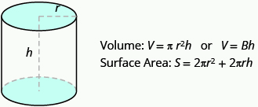

Example:

Input:

r = 10

h = 5

output:

Surface area: 942.48 square units

Volume: 1570.80 cube units

1. Write a python program to calculate the volume of Cone.

Volume:

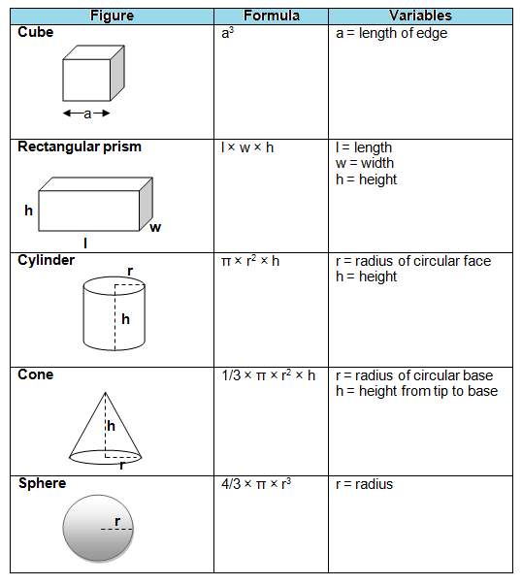

Surface area:

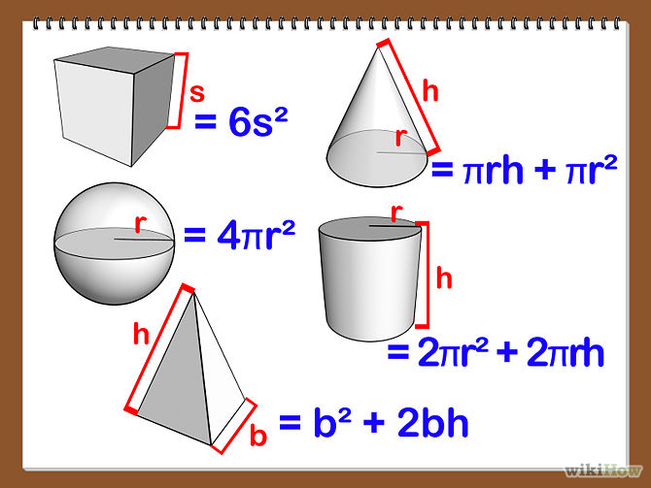

1. Write a python program to calculate the volume of cube.

Volume:



Surface area:



1. Write a python program to calculate the volume of Sphere.

Volume:



Surface area:

